Sugarcane Leaf Disease Dataset
About dataset
This database has been collected in Maharashtra, India. The database is balanced and contains good variety. The image sizes and resolutions are not constant as it originates from various capturing devices.
Aspect
- Number of images: 2,569 images
- Plant diversity: Just Sugarcane.
- Number of classes: 5 classes (Healthy, Mosaic, Redrot, Rust, Yellow)
- Image type: RGB images of sugarcane leaves, collected manually under varied real-world conditions.
- Condition diversity: Wild images.
Conclusion
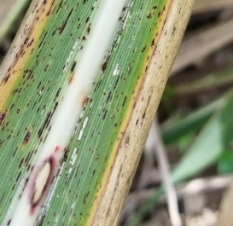
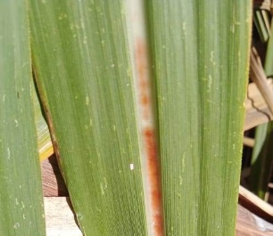
Resize is compulsory, and geometric augmentations are highly recommended for this dataset. The dataset is intended solely for leaf disease classification tasks.
